S:
C.C.: Postmenopausal vaginal bleeding for a week
P.I.: A 77-year-old woman who has suffered from vaginal bleeding for a week and came to OPD. PV showed a cervix tumor with contact bleeding. Colonoscopy revealed a small polyp; cystoscopy revealed no abnormal tissue. After several examination, endometrium malignancy was more favored. (影像報告一開始都打cervical cancer, 如果不直接講明是endometrium cancer恐怕很容易打錯?)

Review of system: vaginal bleeding

O: Performance status: 0
PV: a cervical tumor with bleeding easily.
Images:
- CT: see disc
- PET/CT: see disc

Questions:
- Please describe the image findings in the provided staging CT and PET/CT.
- Stage the patient by the 2018 8TH AJCC staging, and 2018 International federation of gynecology and obstetrics (FIGO) staging.
- What treatment do you recommend for this patient according to the NCCN guideline?
- If radiotherapy is part of your treatment recommendations:
- Please describe the definition of GTV, CTV and PTV.
- Outline GTV, CTV on the provided non-contrast CT image.
- What is/are the prescribed radiotherapy dose(s)?
- How do you evaluate your treatment planning?
- Name the possible radiation side effects.

- Please describe the image findings in the provided staging CT, PET/CT
CT:
Tumor invasion (0-No or Equivocal, 1-Yes)
(1) Cervix (1) Parametrial invasion (Rt ___,Lt _v__)
Regional nodal metastasis (0-No or Equivocal, 1-Yes)
(0) Parametrial (0) Obturator (0) Internal iliac (0) External iliac (0) Common iliac (0) Sacral (0) Para-aortic (1)
A 1.2x0.9cm enlarged paraaortic nodule between aorta and IVC is noted (Se:4 Im:45).
Distant metastasis (In this study)
> Omental cakes with mild ascites are noted, suggestive of peritoneal carcinomatosis.
> A few small nodules (size: <1cm) in visible bilateral lower lung fields are noted, suspiciosus of pulmonary metastases.
PET:
1. There is an FDG avidity involving over uterus & cervix with parametrial involvement (size: about 6.7 cm in length, SUVmax.: ~24.8).
2. Hypermetabolic activity involves the right diaphragm, thickened omentum and peritoneum in the pelvis (SUVmax.: ~10.9).
3. There are multiple FDG-avid nodular lesions in the bil. lung, right hilar region, cardiophrenic angle and aortocaval space (SUVmax.: ~13.5).

- Stage the patient by the 2018 8TH AJCC staging and 2018 International federation of gynecology and obstetrics (FIGO) staging:
(According to American Joint Committee on Cancer, AJCC 8th edition): cT3b N2a M1, stage IVB
(According to FIGO): IVB

- What treatment do you recommend for this patient?
根據2020 NCCN guideline，Suspected extrauterine disease with distant metastasis,
這個病人還有開刀切除primary lesion的可能性下
可選擇 Systemic therapy and/or EBRT and/or SBRT 或 Palliative TH/BSO
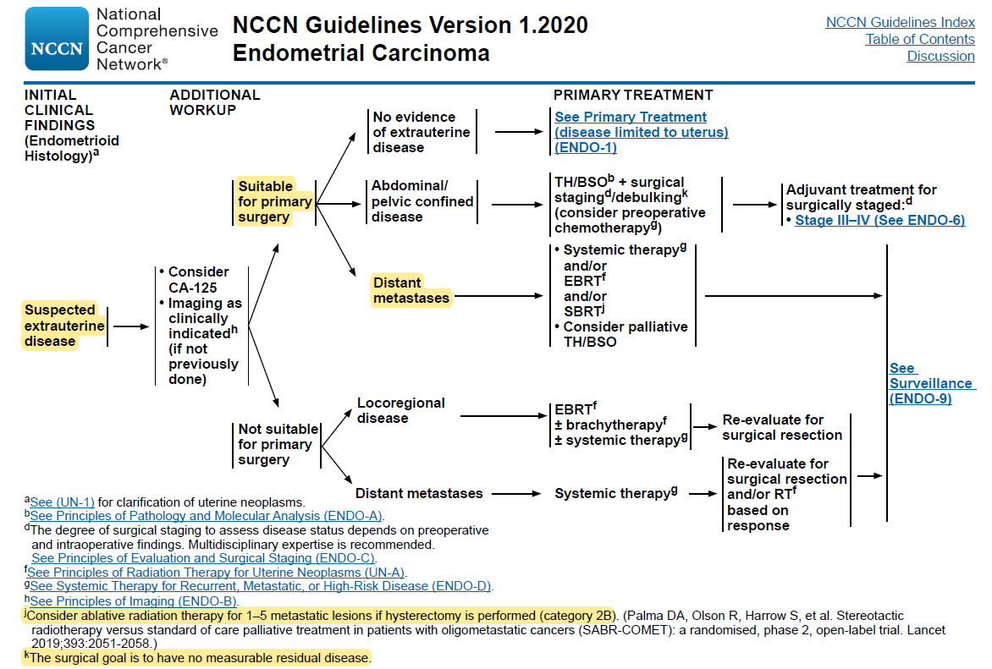
- If radiotherapy is part of your treatment recommendations:
依照NCCN guideline，若選擇RT治療，應是屬於不開刀的方式(Systemetic therapy +RT)。故參考最新版NCCN guide line及2015 ABS guideline規劃放射治療部分。
(1) Please describe the definition of GTV, CTV and PTV.
EBRT:
According to Target Volume Delineation for Conformal and Intensity-Modulated Radiation Therapy by Nancy Y. Lee et al, Handbook of Evidence-Based
Radiation Oncology 3rd Edition by Eric K. Hansen Mack Roach III Editors and RTOG GYN consensus on CTV volumes:
GTV: primary tumor and regional lymph which was identified by PE and image.
CTV:
- The upper border to over the para-aortic CTV LN volumes should at least at 1-2 cm above the level of renal vein or at the top of the L1.
- Use 7 mm margin around the para-aortic vessels and iliac vessels connecting the commom, external and internal iliac contours on each slice, carving out the bowel, bladder, and bone.
- Cover the entire uterus, Parametrim, uterosacral ligaments, sufficient vaginal margin from the gross disease (at least 3 cm).
- Contour presacral nodes (subaortic only) S1–S2, posterior border being the anterior sacrum, and anterior border approximately 10 mm anterior to the anterior sacral bone carving out the bowel, bladder, and bone.
- Stop external iliac CTV node contours at the top of the femoral heads (bony landmark for the inguinal ligament).
- Stop contours of the obturator CTV nodes at the top of the pubis
PTV:CTV + 7-10mm

Brachytherapy (3D based):
CTV: whole uterus + cervix + upper vagina 1-2cm

(2) Outline CTV on the provided non-contrast CT image.
(3) What is/are the radiotherapy dose(s)?
According to the ABS guidelines and NCCN guidelines:
The commonly used dosed for Extended-field EBRT is 45Gy/25fractions QD, followed by para-aortic and pelvic gross LNs boost 10-20Gy (as normal organ tolerant limit) + brachytherapy 5Gy*5 fractions Q2W.

(4) How do you evaluate your treatment planning?
Dose coverage (at EQD2 dose)
GTV: D100≧80 Gy
Brachy CTV D90≧65Gy

Dose constraints (at EQD2 dose)
D2cc to the sigmoid <70-75 Gy,
D2cc to the rectum <70-75 Gy,
D2cc < 90 Gy to the bladder.
Limit upper vaginal mucosa <120 Gy, mid vaginal mucosa <80–90 Gy, and lower vaginal mucosa <60–70 Gy.
Femoral heads: max dose <50Gy
Small bowel: Dmax <45–50.4 Gy, V40 < 30%
Rectum: V30 < 60%
Bladder: V45 < 35%
Bone marrow: V40 <37%.

(5) Name the possible radiation side effects.
Acute toxicity: urgency, frequency, nocturia, dysuria, diarrhea, rectal irritation, pain,
bleeding, fatigue
Subacute and late toxicity: vaginal stenosis, ureteral stricture, vesicovaginal or rectovaginal fistula, bowel obstruction, bowel perforation, femoral neck necrosis

